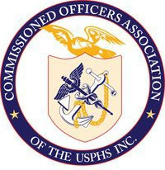
District of Columbia

Commissioned Officers Association (DC COA)
United States Public Health Service

District of Columbia Commissioned Officers Association

LCDR Agatha D’Costa, MSN, ANP-BC

Member at-large

Nurse Category

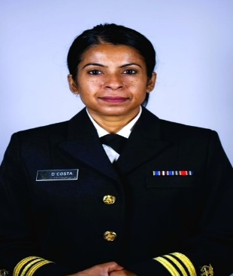
LCDR Agatha Lucky D’Costa is a board-certified adult nurse practitioner (ANP-BC). She was commissioned into the United States Public Health Service in September 2013. From 2013 – 2021, LCDR D’Costa was stationed at Defense Health Agency, Virginia. There she played a key role as a contract officer representative in ensuring the successful implementation of the military’s first Nurse Advise Line. During her tenure at DHA, she also advanced in the role of a Program Manager for the Supplemental HealthCare Program. She assisted in managing health care policy and benefits for active-duty service members. In 2021, LCDR D’Costa transferred duty station to Health Resources and Service Administration (HRSA), Maryland. As a nurse reviewer at Countermeasures Injury Compensation Program, she reviews claims for vaccine related injuries and assists with determination for compensation.
LCDR Agatha D’Costa was born in Bangladesh. In 1988, she immigrated to the United States with her family. She grew up in the DC/MD/VA area. LCDR D’Costa earned her Bachelor of Science in Nursing in 2002 from The Catholic University of America (CUA), District of Columbia (DC). She also earned her Master of Science in Nursing at CUA in 2007. Prior to joining the service, LCDR D’Costa worked as a staff nurse in the cardiology unit at Washington Hospital Center, DC. After grad school, she worked as a nurse practitioner at Walter Reed Army Hospital and at Kimbrough Ambulatory Care Center, Fort George Meade, MD. While maintaining her full-time position as an ANP-BC, she also worked as an independent contractor for LHI for more than ten years. She provided health education and performed annual health assessments among the military reservists in various reserve locations in the east coast.
LCDR D’Costa is the youngest of four children. She is a loving daughter, a sister, a mother, and a caring friend. She is the mother of two very happy and energetic kids, Ava, and Eli, in addition to her puppy, Kori. LCDR D’Costa prioritizes her physical and mental health daily by exercising, meditating, praying, journaling, and maintaining a healthy diet. She believes in empowering others by being a positive role model.

